Aashwin Basnet

Last updated on 05/21/2019 at 4:00 PM

Documentation on Java Coincide App

**FIRST THING FIRST**

Before you attempt to compile and run any java files in your computer, make sure you have these programs installed on your computer:

1. Install Java to your computer from this link: <https://www.oracle.com/technetwork/java/javase/downloads/index.html>

Make sure you keep on updating this every now and then.

A screenshot of “Programs and Features” in the control panel of my computer at this stage (05/21/2019) looks like this:

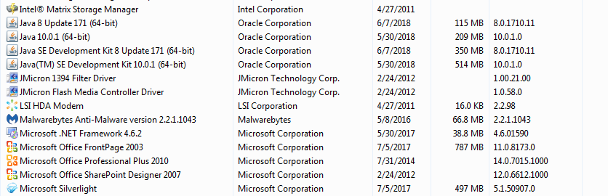

So there are four Java programs (SE, JDK) installed right now.

1. Download Eclipse. As of 05/21/2019, I am using Eclipse Java Oxygen Version 0.3A. I downloaded it from here: <https://www.eclipse.org/oxygen/>

* Where to find the Java .class file?

>> Go to Spring 2019_Aashwin\Java\bin\coincide_front_end_master

You can also find everything in my github. Just download it from github:

<https://github.com/abasnet1/javaproject_spring2019>

* What is a .class file?

>> A Java .class file is basically the bytecode produced by our compiler or simply, it is compiled .java file. This is the file that you run on JVM (Java Virtual Machine) to execute the application.

* The latest version of coincideapp that I have as of 05/21/2019 is called “coincide” compiled on 01/31/2019. If you ever need to make change to the Java code and create a new executable .exe file, follow the steps below:

1. Open Eclipse Java Oxygen (As of 04/22/2019, I have oxygen 0.3A)
2. You should see this screen where it asks you to choose your workbench.

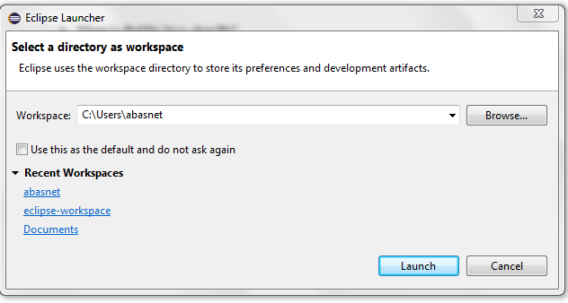

I have mine under C:\Users\abasnet, but you can always create a new one. Once I log my trinity credentials out of this computer, you will not be able to access this folder. But you can change workspace directory anytime.

1. Next, eclipse will run with all the .java files that you have loaded in the workspace (before you terminated eclipse last time.)
2. Let’s say you make some changes in the main .java file called “CoincideGUI.java”, and now you want to see if you can run this (without actually creating an executable jar file), all you have to do is click Run (green play button) on the top region.

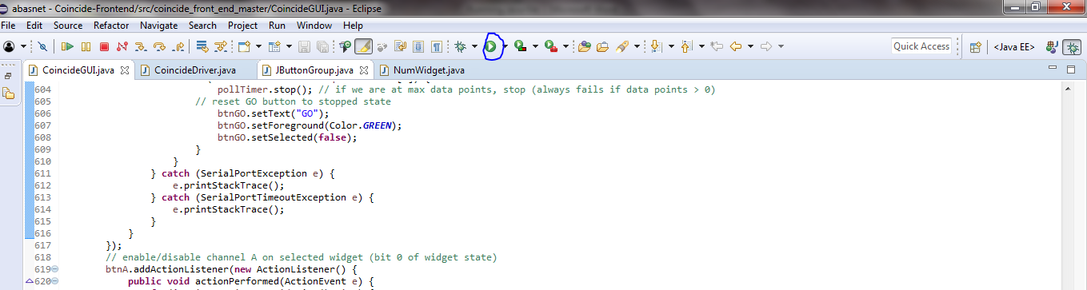

If there are no errors in the code, the GUI should run. You can run the app by feeding some signals and also write them on a .txt file. More on this later.

1. In order to create an executable jar file, click File >> Export >> Java >> Runnable Jar File. You should see a screen like this:

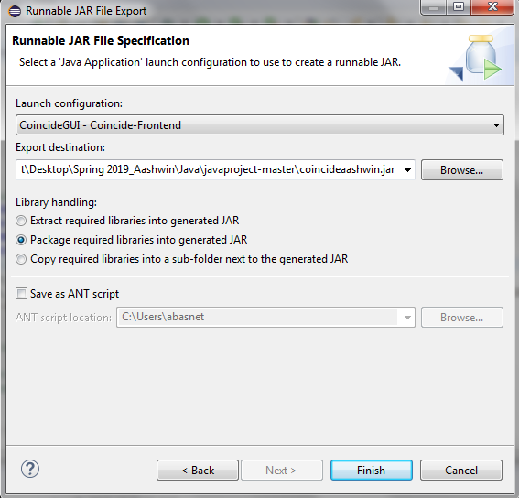

Make sure you check your “Launch Configuration” is the same one that you are using to run the .java file. Here, my “Launch Configuration” is CoincideGUI-Coincide-Frontend.

**Carefully choose your export destination (mine is the same folder where the main java file is). This is very important.** Also, make sure you choose “Package required libraries into generate Jar.” Also you change the name of the executable file at the end of the directory path in the “Export Destination” box above. At the time I was writing this part of the documentation, I created the file as “coincideaashwin.” (Of course this has changed as of 05/21/2019.) Click “Finish”.

For some reason, which I have not been able to figure out yet as of 04/25/2019, the executable jar file does not run on this computer simply by double-clicking. I strongly believe that I messed up somewhere when I was installing Java JRE/JDE cause it runs perfectly fine in my personal computer. So what I do is run the executable jar file using command prompt:

**Running Java executable .jar file in command prompt**

1. In this computer, click windows logo on the bottom left. In “Search Program and files” type run and then cmd and click enter.
2. Then in the command window, by default, my directory is C:\Users\abasnet\. Your job is to change this directory to the place where your executable .jar file is.
3. You should change this to go to the directory where your java executable file is. What you do is type this in cmd. (Notice that it will be different for you.)

cd Desktop\Spring 2019_Aashwin\Java\

You will now be in the folder where your java .exe file is.

1. Type this in java

java[space]–jar[space]<app-name>.jar

E.g. java –jar coincide.jar

If your file was properly compiled without any error, it should run.

**Writing data from coincide GUI app to a .txt file**

1. Connect the mojo to the computer.
2. Open the coincide app using steps given above.
3. Under “Settings” tab in the app, go to “Serial Port” and select the right serial port.
4. Under “Output Filename”, choose the name you want. The app does have a default naming for each run.
5. Then, click “Connect.”
6. Then, “Write.”
7. Go to “Data” tab on the top left.
8. Click “Go.”
9. Once you have the amount of data you need. Just Click “Stop.”
10. Go to “Data” tab again and click “Don’t Write.”
11. “Disconnect” the mojo.
12. The file will be saved in the same folder where the coincidenew app is. If you did not put any “Output filename”, the default file name is ‘date_time.’

Note that everytime you want to change the port for mojo, I recommend closing the coincide app and running it again because the app does not have an in-built port refreshing mechanism. And if you change the port without closing the app, the app will not get signal.

**Running Configurations For CoincideGUI.Java**

Sometimes, when you try to run Java, it says there is no launch history as shown in pic 1. I have faced this problem a number of times. I am also pretty sure that if you take the java file to a new computer with a freshly installed eclipse, you will incur this problem. In that case, you cannot run the application inside JAVA and cannot export it as a runnable jar file. In that case, take following steps.

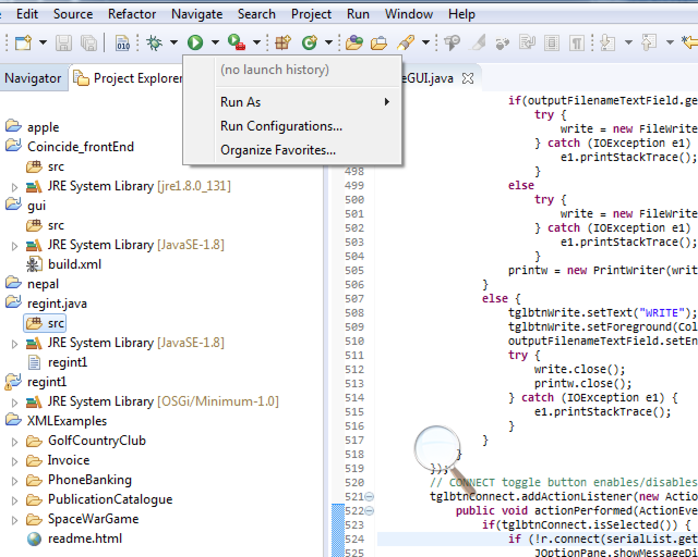

Fig 1: By clicking on the small downward arrow on Run, you will see these options.

Steps:

1. In Eclipse, in the project explorer pane (you can see that on the figure above on left side), right click and choose **Import** and then do either of the following:
2. Expand “General” and click “**Projects from folder or archive**.” Then, just type this on **“Import Source”**: C:\Users\trinlab\git\javaproject

Note: At this point, this folder has the most updated version of Java files from the entire research work we have done up to today. And this already has the configuration that we need to run for this GUI. If you have a separate folder for your project, this method will not work.

Update: As of 05/21/2019, the folder “git” does not exist, so this method does not work.

1. Instead of step a), try File>Import> Git>Projects from Git. Again, I assume that Git has been installed in the computer and you can easily find techniques to do so in the internet in case it is not installed. Then, click Clone URI and then copy and paste [**git@github.com:abasnet1/javaproject.git**](mailto:git@github.com:abasnet1/javaproject.git)on URI and for protocol (shown in figure below), choose https. Then click Next and you should be all set after few more easy steps.

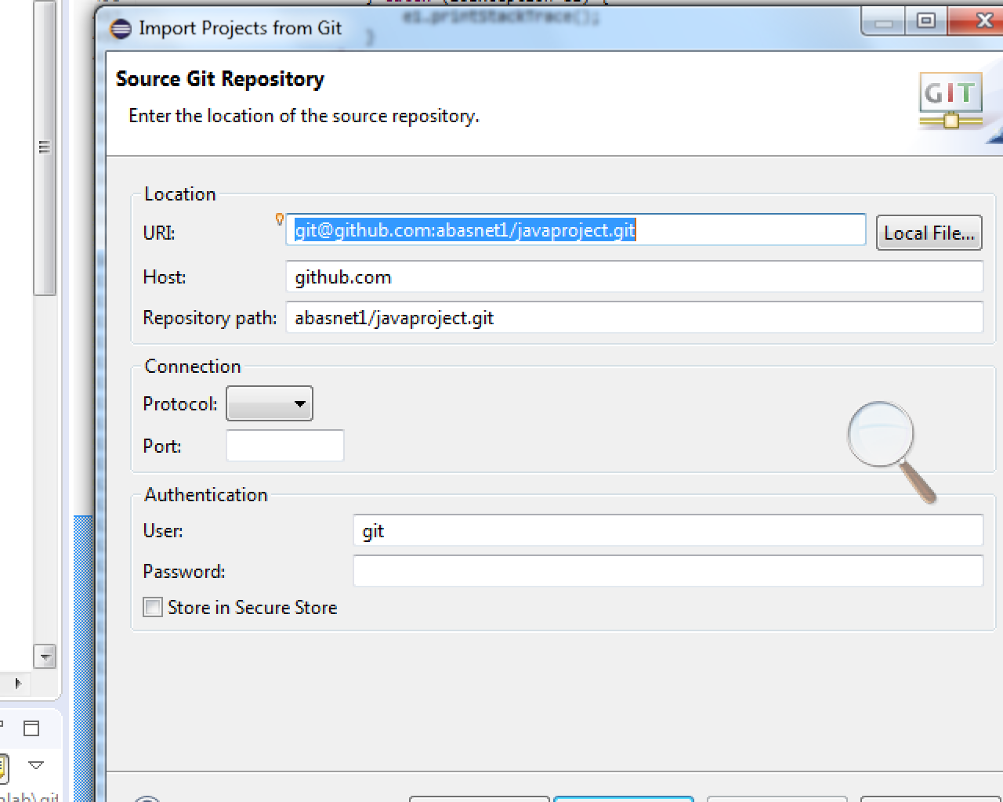After following one of these steps, you should see your project in the project explorer windows. Mine looks something like this:

**Choose HTTPS here!**

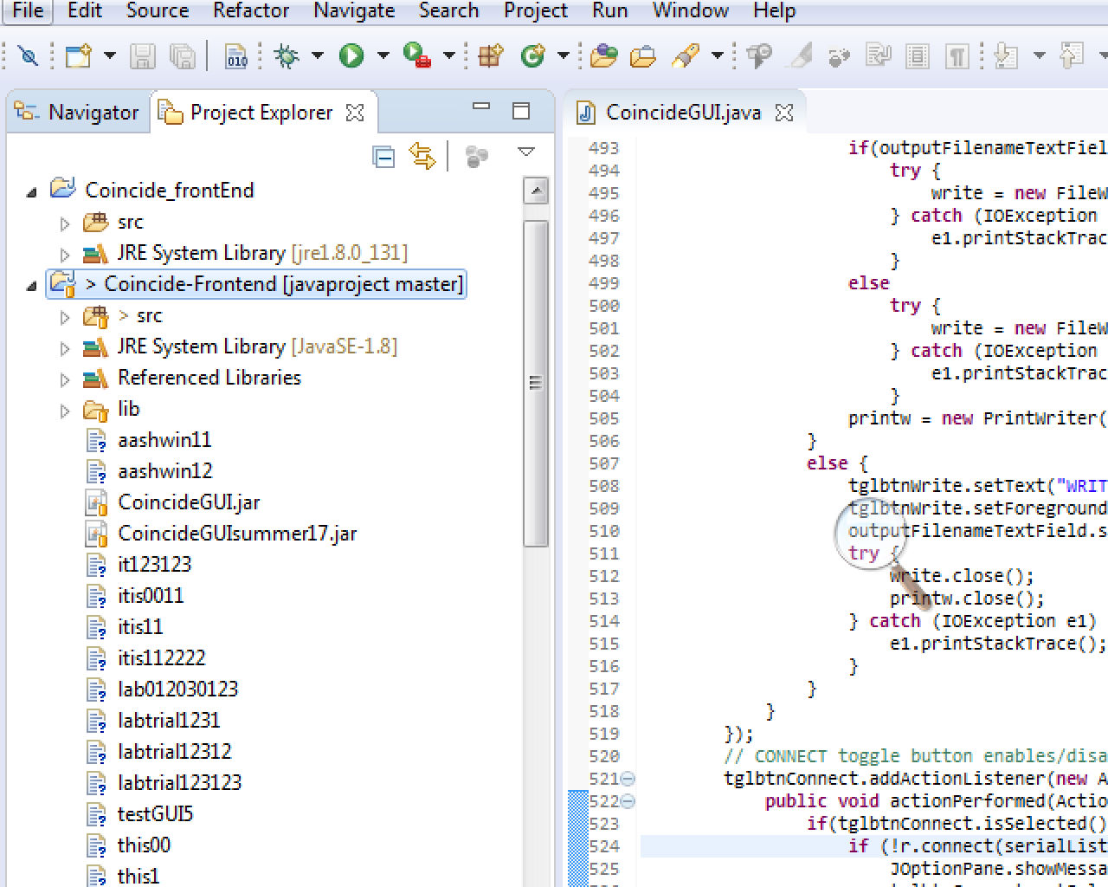

So the red underlined project is the one I just imported and if you open its sub folders, you will see src and then double click on coincide_front_end_master and choose coincideGUI. You are all set.

Now, once you do that, if you try to run this program, you will see something like this:

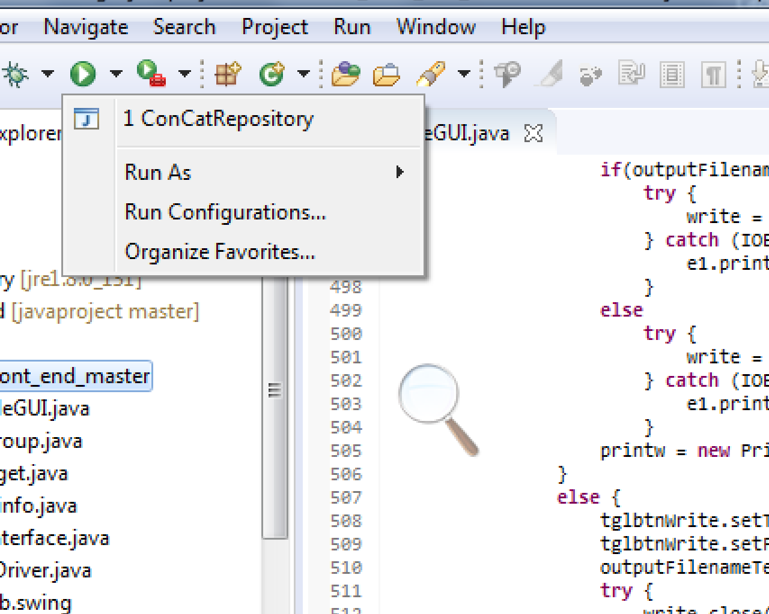

In order to run the GUI, just click on *concat repository* and you should be all set.

How to **use the write to file function** in GUI?

Steps:

1. Open the GUI.
2. Go to Settings tab.
3. First make sure that the mojo is connected to your computer or pi by choosing appropriate ports from *Serial Port* option.
4. Before start writing, I recommend just clicking *connect* on bottom left side side of GUI under settings tab to make sure the mojo is connected. Also, go to data tab and check if it actually shows some counts. If you want a fresh set of data, make sure you unselected all the windows, go back to settings tab and then Disconnect the mojo.
5. Go back to settings tab and write a file name under *Output Filename* option.
6. Then click *Connect* and then *Write.*
7. Go back to data tab and choose any windows or combination of windows you want to take counts from and click *Go.*
8. Once you are done, press *Stop* on bottom left of data tab.
9. Go back to settings tab and click *Don’t Write*.
10. You should be all set! Your file should be in the folder where your project folder is. If you do not know that, just use windows explorer and search for your file.